Project Planning and Management Plan
AI Interview Preparation Agent | DEPI Project | Version 1.0 | October 2026

1. Project Overview
The AI Interview Preparation Agent is an agentic AI platform that simulates a realistic job interview for a candidate based on a specific job opportunity. The user provides a job URL or a job description file and, optionally, a CV. The system analyzes the job requirements and the candidate profile, identifies skill gaps, builds a personalized interview plan, conducts an adaptive interview (text or voice), evaluates every answer, and finally produces a detailed performance report with a personalized learning roadmap.
Unlike a chatbot that generates static questions, the platform is built as a multi-agent system. A central Orchestrator Agent coordinates specialized agents (Job Analyzer, Candidate Analyzer, Interview Planner, Adaptive Interviewer, Answer Evaluator, Learning Agent, Report Generator) and gives them access to tools such as web search, a job page reader, a RAG knowledge base, speech-to-text and text-to-speech. Short-term and long-term memory allow the system to remember previous interviews and adapt future preparation.

2. Project Objectives
- Build an end-to-end platform that turns a job posting and a CV into a personalized, adaptive mock interview.
- Evaluate each answer on multiple dimensions (technical accuracy, completeness, communication, relevance, problem solving) and give actionable feedback.
- Adapt question difficulty and topic selection in real time based on candidate performance.
- Track progress across interviews using long-term memory and generate personalized learning plans.
- Demonstrate core Agentic AI concepts: orchestration, tool use, function calling, memory, RAG, planning and decision making.
- Deliver a working system, full documentation, testing evidence and a final presentation by 4 December 2026.

3. Scope

3.1 In Scope
- Job input via URL, PDF, TXT or DOCX, and optional CV upload with structured parsing.
- Job analysis, candidate analysis and gap analysis.
- Interview planning, adaptive questioning, follow-up questions and behavioral (STAR-based) evaluation.
- Answer evaluation with scores, feedback and a suggested better answer.
- Optional voice interview using speech-to-text and text-to-speech.
- RAG knowledge base of interview questions and concepts.
- Short-term and long-term memory, interview history and progress tracking.
- Learning resource search, learning plan and final report.
- Web dashboard with performance charts.

3.2 Out of Scope
- Native mobile applications.
- Integration with real employer hiring systems or applicant tracking systems.
- Video-based analysis of facial expressions or body language.
- Guaranteeing real interview outcomes or acting as a recruitment decision tool.

4. Deliverables and Milestones
The following deliverables and deadlines are set by the DEPI program schedule.
Deliverable | Deadline
Project Planning and Management | 16 Oct 2026
Literature Review | 16 Oct 2026
Requirements Gathering | 16 Oct 2026
System Analysis and Design | 6 Nov 2026
Implementation (Source Code and Execution) | 30 Nov 2026
Final Presentation, Testing and Reports | 4 Dec 2026

5. Work Breakdown and Timeline
The project runs for about eight weeks, from early October to 4 December 2026, in five phases.
Phase | Main Activities | Period | Output
1. Initiation and Planning | Define vision, scope, team roles, tools, risks and schedule | 1 - 16 Oct | This plan
2. Research and Requirements | Literature review, competitor analysis, requirements gathering, user stories | 1 - 16 Oct | Literature review, SRS
3. Analysis and Design | Architecture, agent design, database schema, API design, UI wireframes, prompt and tool design | 17 Oct - 6 Nov | Design document, diagrams
4. Implementation | Backend, agents, RAG, memory, voice, frontend and integration, in three sprints | 7 - 30 Nov | Working system
5. Testing, Reporting and Presentation | Functional and agent evaluation testing, bug fixing, final report, demo preparation | 24 Nov - 4 Dec | Test report, final presentation

5.1 Implementation Sprints
Sprint | Dates | Goals
Sprint 1 | 7 - 14 Nov | Project skeleton, database, job and CV input, Job Analyzer, Candidate Analyzer, gap analysis
Sprint 2 | 15 - 22 Nov | Interview Planner, Adaptive Interviewer, Answer Evaluator, RAG knowledge base, memory
Sprint 3 | 23 - 30 Nov | Learning Agent, Report Generator, dashboard, voice interview, integration and bug fixing

5.2 Gantt Chart
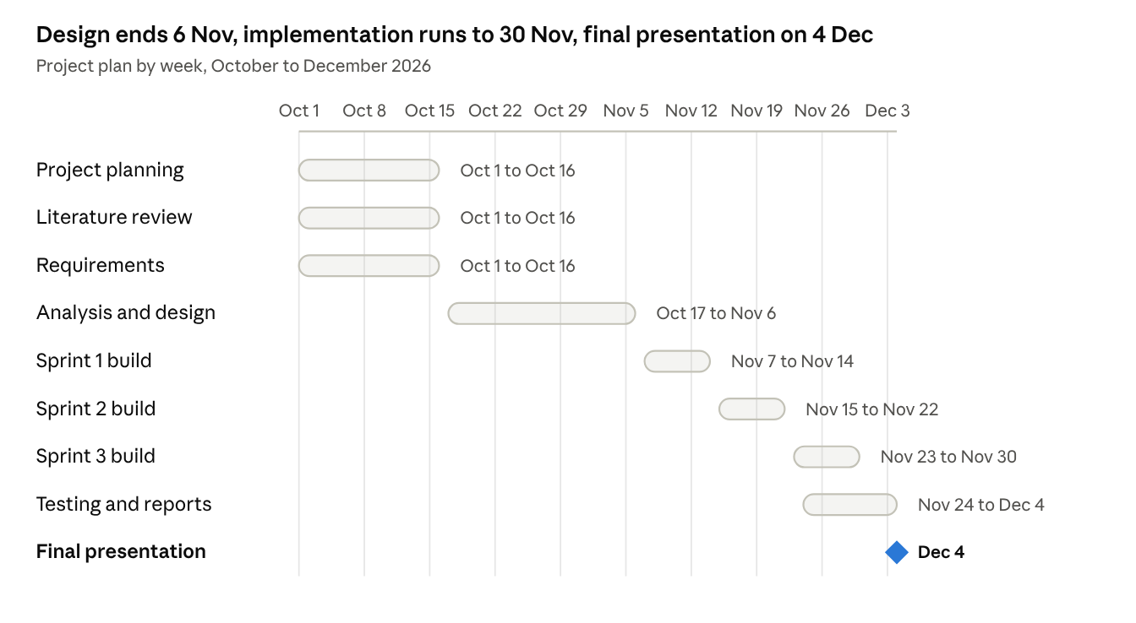
Gantt chart · 9 rows, 1 milestone
Planning, literature review and requirements run in parallel until 16 Oct; design follows until 6 Nov, then three build sprints, with testing and the final presentation closing on 4 Dec.

6. Team Structure and Responsibilities
The team members and exact allocation are to be completed by the team. A suggested split of roles is shown below.
Role | Responsibilities | Assigned To
Project Manager / Scrum Master | Planning, tracking, meetings, risk follow-up | [Name]
AI / Agents Engineer | Orchestrator, agents, prompts, tool calling | [Name]
RAG and Data Engineer | Knowledge base, embeddings, vector database, memory | [Name]
Backend Engineer | FastAPI services, PostgreSQL, authentication, APIs | [Name]
Frontend Engineer | Dashboard, interview screen, charts, voice UI | [Name]
QA and Documentation | Test cases, evaluation, reports, presentation | [Name]

7. Task Assignment
Every deliverable has a clear owner and a due date; the owners are roles from the table above, and names will be filled in by the team.
Task | Phase | Owner (role) | Due
Project proposal, plan, risk plan and KPIs | Planning | Project Manager | 16 Oct 2026
Literature review of agents, RAG, memory and evaluation | Research | AI / Agents Engineer, RAG and Data Engineer | 16 Oct 2026
Requirements, personas, user stories and validation survey | Requirements | QA and Documentation, Project Manager | 16 Oct 2026
Architecture, use case, DFD, sequence, activity, state and class diagrams | Analysis and Design | AI / Agents Engineer, Backend Engineer | 6 Nov 2026
ER diagram, logical and physical schema | Analysis and Design | Backend Engineer | 6 Nov 2026
Agent prompts, tool schemas and orchestration graph design | Analysis and Design | AI / Agents Engineer | 6 Nov 2026
UI/UX wireframes, mockups and guidelines | Analysis and Design | Frontend Engineer | 6 Nov 2026
Backend APIs, authentication and database | Implementation | Backend Engineer | 30 Nov 2026
Job and candidate analyzers, gap analysis, planner, adaptive interviewer, evaluator | Implementation | AI / Agents Engineer | 30 Nov 2026
RAG knowledge base, embeddings and memory | Implementation | RAG and Data Engineer | 30 Nov 2026
Dashboard, interview screen, charts | Implementation | Frontend Engineer | 30 Nov 2026
Voice interview (speech-to-text and text-to-speech) | Implementation | AI / Agents Engineer, Frontend Engineer | 30 Nov 2026
Test plan, test cases, automated tests and bug reports | Testing | QA and Documentation (all members fix bugs) | 4 Dec 2026
User manual, technical documentation, README, presentation and demo video | Final reports | QA and Documentation, Project Manager | 4 Dec 2026
Upload every document and the source code to GitHub | All phases | Project Manager | At each deadline

8. Resource Allocation

8.1 Human Resources
Effort level of each role in every phase (High, Medium, Low):
Role | Planning and Research | Analysis and Design | Implementation | Testing and Reports
Project Manager / Scrum Master | High | Medium | Medium | High
AI / Agents Engineer | Medium | High | High | Medium
RAG and Data Engineer | Medium | Medium | High | Medium
Backend Engineer | Low | High | High | Medium
Frontend Engineer | Low | Medium | High | Medium
QA and Documentation | High | Medium | Medium | High

8.2 Tools and Infrastructure
Resource | Purpose | Source
GitHub | Version control, documentation, issues and project board | Free
Task board (GitHub Projects or similar) | Sprint and task tracking | Free
LLM API | Agents, question generation and evaluation | Paid usage or credits; usage limits set during testing
Speech-to-text and text-to-speech APIs | Voice interview | Free tier or paid usage
Web search API | Company research and learning resources | Free tier or paid usage
PostgreSQL and vector store | Application data, memory and RAG | Run locally or in containers; free
Hosting for the demo | Deployed version of the web app | Free tier or a low-cost cloud instance
Team laptops | Development and testing | Owned by team members

8.3 Budget
The main cost is API usage (LLM, speech and search). The team will use free tiers and credits where possible, cache repeated calls, and set a usage cap during testing. The final estimate will be confirmed once the API providers are chosen in the design phase.

9. Methodology
The team follows an Agile, sprint-based approach adapted to the short DEPI timeline. Planning and design phases are completed first, then implementation is split into one-week sprints with a short planning session at the start and a review at the end. Progress is tracked on a shared task board with the states To Do, In Progress, In Review and Done. A short weekly meeting reviews progress, blockers and next steps.

10. Technology Stack
Area | Technology
Backend | Python, FastAPI
Agent framework | LangGraph (primary option), LangChain; CrewAI as an alternative
Relational database | PostgreSQL
Vector database | A vector store such as pgvector, Qdrant or Chroma (final choice during design)
LLM | LLM API with structured outputs and function calling
Speech | Speech-to-text and text-to-speech APIs
Web search | Web search API for company and learning resource research
Frontend | Web dashboard (React or a similar framework)
Collaboration | GitHub for version control, a shared task board, shared documentation

11. Risk Assessment and Mitigation Plan
ID | Risk | Likelihood | Impact | Mitigation
R1 | Short timeline versus a large feature set | High | High | Prioritize features (MoSCoW); voice and company research are optional stretch goals
R2 | LLM hallucination or inconsistent evaluation scores | Medium | High | Structured outputs, scoring rubrics, RAG grounding, test set of sample answers
R3 | Job page scraping fails or is blocked | Medium | Medium | Fallback to file upload or pasted text
R4 | API cost and rate limits | Medium | Medium | Caching, smaller models for simple tasks, usage limits during testing
R5 | Latency in voice interview | Medium | Medium | Streaming where possible; text mode as default
R6 | Integration problems between agents | Medium | High | Clear state schema, early integration in Sprint 1, regular end-to-end tests
R7 | Handling personal data in CVs | Low | High | Store only what is needed, secure storage, clear user consent and deletion option
R8 | Team member unavailability | Low | Medium | Shared documentation, pair work on critical modules

12. Key Performance Indicators
The project is measured against the following targets; they will be checked during testing and reported in the final report.
Category | KPI | Target | How It Is Measured
Performance | Response time for the next question | 10 seconds or less for 95% of questions | Timing logs during test interviews
Reliability | System uptime during testing and demo | 95% or higher | Monitoring and error logs
Accuracy | Required skills correctly extracted from job postings | 90% or higher on a set of 20 test postings | Manual comparison with a reference list
Evaluation quality | Score consistency when the same answer is scored repeatedly | Difference of 1 point or less out of 10 | Repeated scoring of a set of sample answers
Adaptation | Test scenarios where difficulty changes correctly (up after strong answers, down after weak ones) | 90% or higher | Scripted scenarios with strong and weak answers
Personalization | Weak skills from a previous interview reflected in the next plan | 100% of test cases | Two-interview test scenarios
Code quality | Unit test coverage of core modules | 70% or higher | Coverage report
User adoption | Testers who complete at least one full interview | At least 20 testers | Usage records
User satisfaction | Average tester rating of usefulness | 4 out of 5 or higher | Feedback form
Delivery | DEPI deliverables submitted on time | 6 of 6 | Submission dates
Delivery | Planned sprint tasks completed | 80% or higher per sprint | Task board

13. Quality Assurance
- Code reviews through pull requests before merging.
- Unit tests for parsers, tools and database operations.
- Integration tests for the full flow from job input to final report.
- Agent evaluation: a set of sample answers (strong, average and weak) to check that scoring is consistent and difficulty adapts correctly.
- User acceptance testing with a small group of student testers before the final presentation.

14. Communication Plan
Activity | Frequency | Purpose
Team stand-up or sync | Twice a week | Progress and blockers
Sprint planning and review | Weekly during implementation | Goals and demo of finished work
Mentor meeting | As scheduled by DEPI | Feedback and approvals
Task board update | Daily | Transparency

15. Success Criteria
- The system completes the full workflow: job input, analysis, gap analysis, adaptive interview, evaluation, report and learning plan.
- Question difficulty visibly adapts to answer quality in test scenarios.
- Memory is demonstrated by using a previous interview to influence the next one.
- All six DEPI deliverables are submitted on or before their deadlines.
- The final presentation includes a live demo and the system architecture.

